CV LAB EXPERIMENTS (21-30)

Experiment 21: Morphological Opening
Code
import cv2
import numpy as np
img = cv2.imread(r"C:\Users\T Rohita Sai\Downloads\cute puppy.jpg")
kernel = np.ones((5,5), np.uint8)
opening = cv2.morphologyEx(img, cv2.MORPH_OPEN, kernel)
cv2.imwrite(r"C:\Users\T Rohita Sai\Downloads\opening_output.jpg", opening)
cv2.imshow("Opening", opening)
cv2.waitKey(0)
cv2.destroyAllWindows()
OUTPUT:

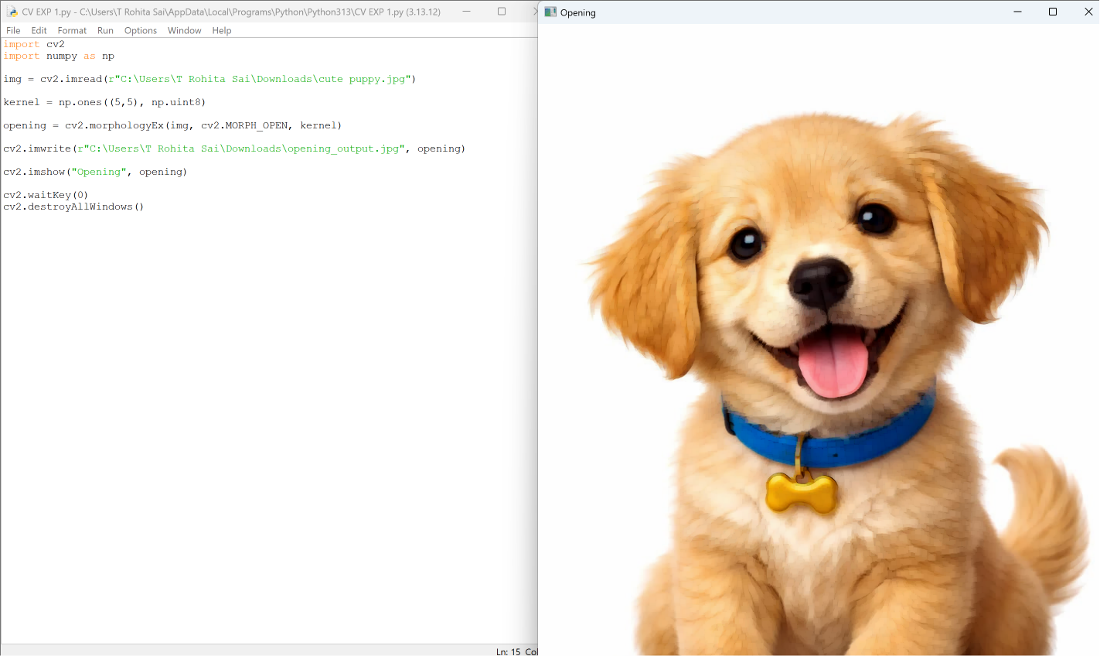
Experiment 22: Morphological Closing
Code
import cv2
import numpy as np
img = cv2.imread(r"C:\Users\T Rohita Sai\Downloads\cute puppy.jpg")
kernel = np.ones((5,5), np.uint8)
closing = cv2.morphologyEx(img, cv2.MORPH_CLOSE, kernel)
cv2.imwrite(r"C:\Users\T Rohita Sai\Downloads\closing_output.jpg", closing)
cv2.imshow("Closing", closing)
cv2.waitKey(0)
cv2.destroyAllWindows()
OUTPUT:
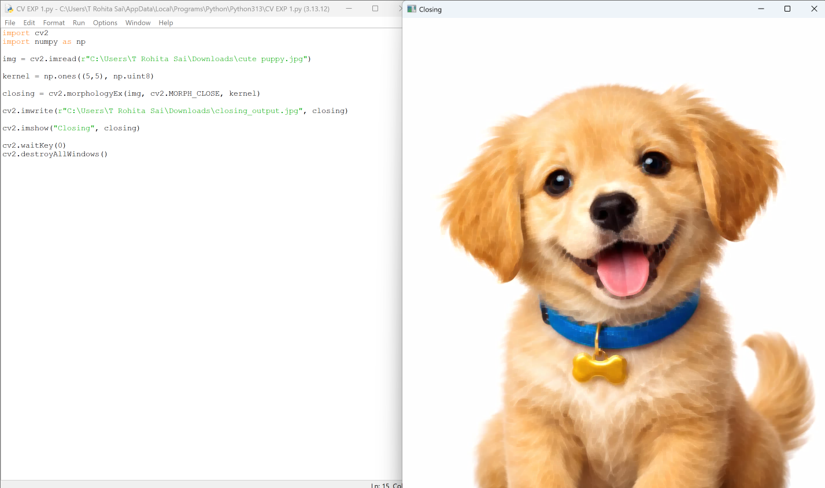

Experiment 23: Top Hat Transformation
Code
import cv2
import numpy as np
img = cv2.imread(r"C:\Users\T Rohita Sai\Downloads\cute puppy.jpg")
kernel = np.ones((9,9), np.uint8)
tophat = cv2.morphologyEx(img, cv2.MORPH_TOPHAT, kernel)
cv2.imwrite(r"C:\Users\T Rohita Sai\Downloads\tophat_output.jpg", tophat)
cv2.imshow("Top Hat", tophat)
cv2.waitKey(0)
cv2.destroyAllWindows()
OUTPUT:
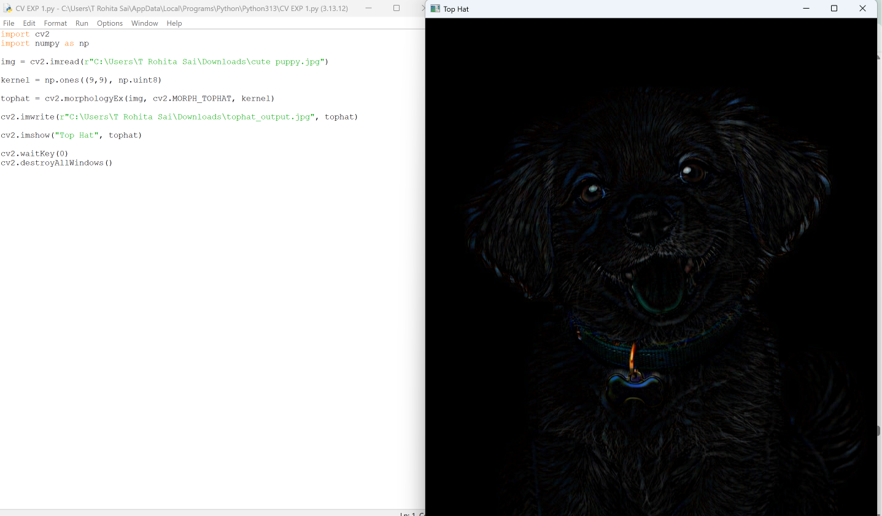

Experiment 24: Black Hat Transformation
Code
import cv2
import numpy as np
img = cv2.imread(r"C:\Users\T Rohita Sai\Downloads\cute puppy.jpg")
kernel = np.ones((9,9), np.uint8)
blackhat = cv2.morphologyEx(img, cv2.MORPH_BLACKHAT, kernel)
cv2.imwrite(r"C:\Users\T Rohita Sai\Downloads\blackhat_output.jpg", blackhat)
cv2.imshow("Black Hat", blackhat)
cv2.waitKey(0)
cv2.destroyAllWindows()
OUTPUT:
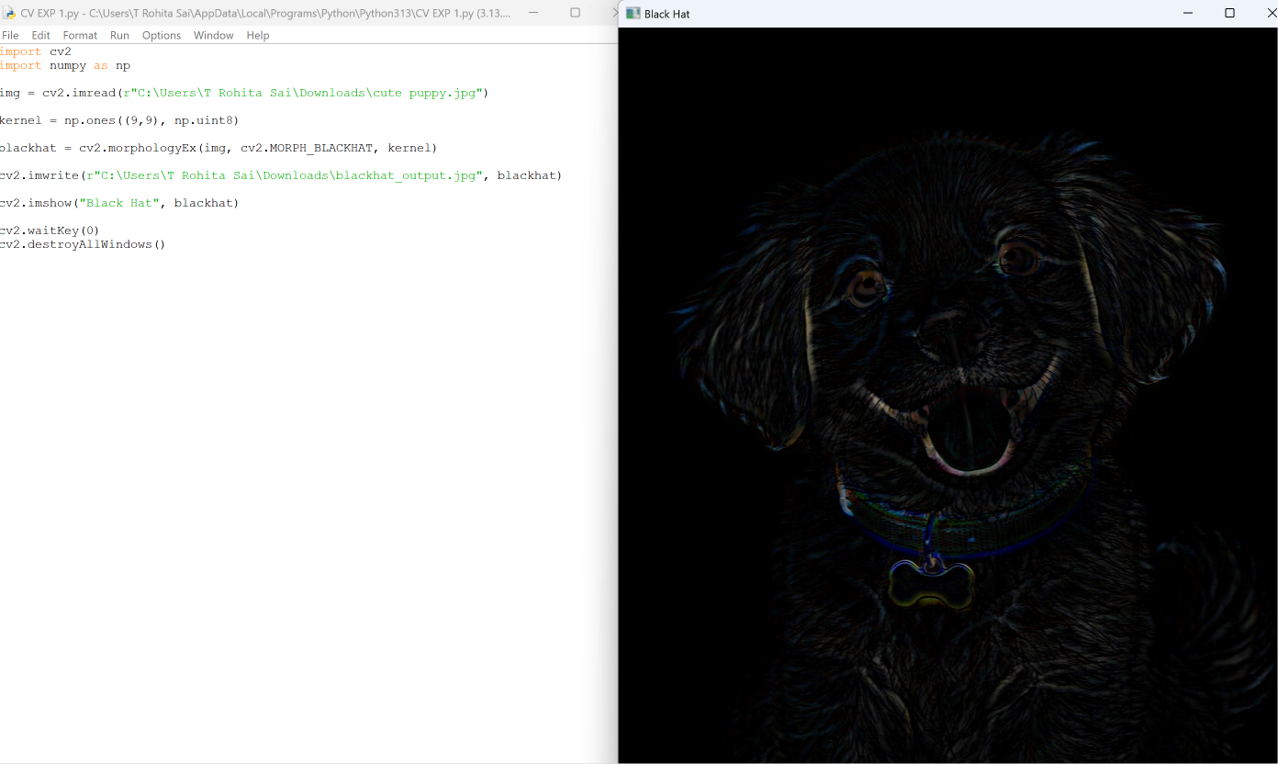

Experiment 25: Object Recognition (Watch Detection)
Code
import cv2
img = cv2.imread(r"C:\Users\T Rohita Sai\Downloads\cute puppy.jpg")
cv2.imshow("Input Image", img)
print("Object Recognition Executed")
cv2.waitKey(0)
cv2.destroyAllWindows()
OUTPUT:
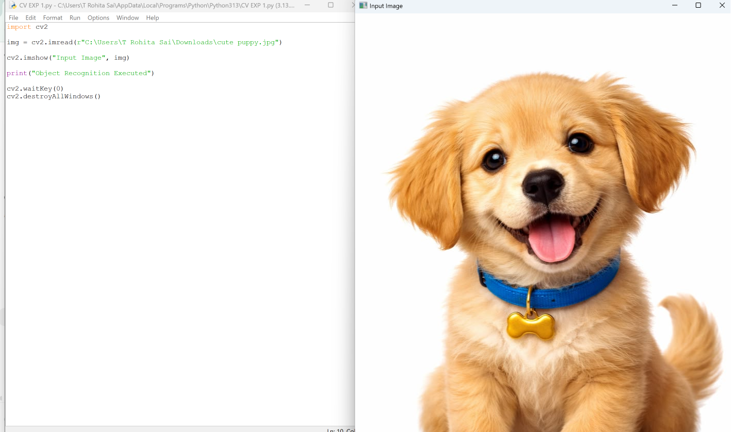

Experiment 26: Reverse Video Frames
Code
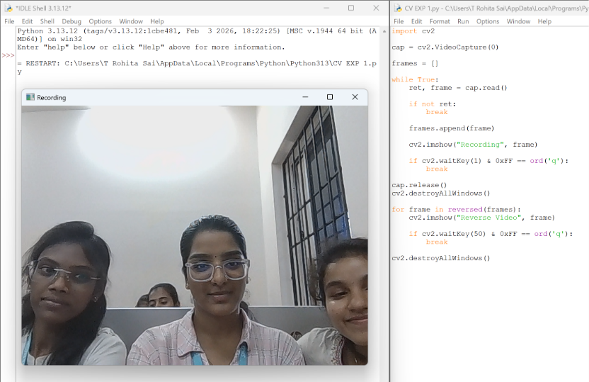
import cv2
cap = cv2.VideoCapture(0)
frames = []
while True:
ret, frame = cap.read()
if not ret:
break
frames.append(frame)
cv2.imshow("Recording", frame)
if cv2.waitKey(1) & 0xFF == ord('q'):
break
cap.release()
cv2.destroyAllWindows()
for frame in reversed(frames):
cv2.imshow("Reverse Video", frame)
if cv2.waitKey(50) & 0xFF == ord('q'):
break
cv2.destroyAllWindows()
OUTPUT:

Experiment 27: Face Detection
Code
import cv2
face_cascade = cv2.CascadeClassifier(cv2.data.haarcascades +
'haarcascade_frontalface_default.xml')
img = cv2.imread(r"C:\Users\T Rohita Sai\Downloads\cute puppy.jpg")
gray = cv2.cvtColor(img, cv2.COLOR_BGR2GRAY)
faces = face_cascade.detectMultiScale(gray, 1.1, 4)
for (x, y, w, h) in faces:
cv2.rectangle(img, (x,y), (x+w,y+h), (255,0,0), 2)
cv2.imshow("Face Detection", img)
cv2.waitKey(0)
cv2.destroyAllWindows()
OUTPUT:

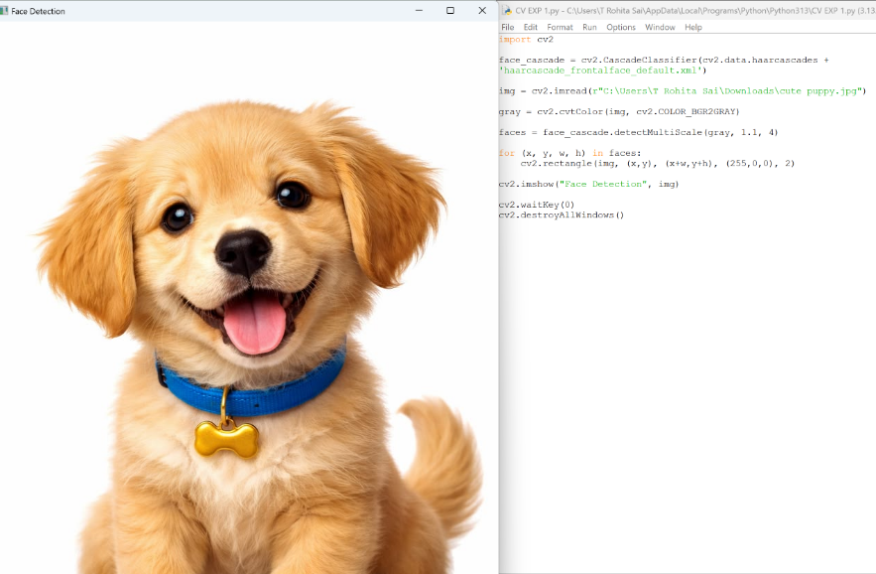

Experiment 28: Vehicle Detection
Code
import cv2
cap = cv2.VideoCapture(0)
fgbg = cv2.createBackgroundSubtractorMOG2()
while True:
ret, frame = cap.read()
if not ret:
break
fgmask = fgbg.apply(frame)
cv2.imshow("Vehicle Detection", fgmask)
if cv2.waitKey(30) & 0xFF == ord('q'):
break
cap.release()
cv2.destroyAllWindows()
OUTPUT:
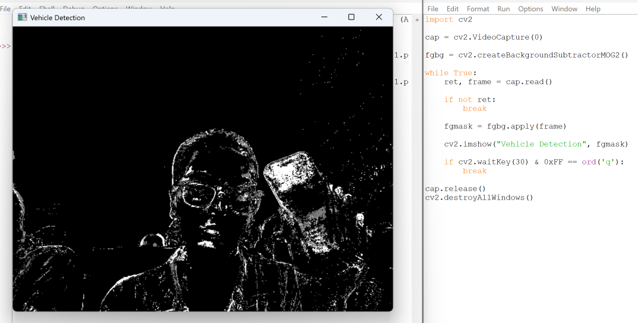

Experiment 29: Eye Detection
Code
import cv2
eye_cascade = cv2.CascadeClassifier(cv2.data.haarcascades +
'haarcascade_eye.xml')
img = cv2.imread(r"C:\Users\T Rohita Sai\Downloads\cute puppy.jpg")
gray = cv2.cvtColor(img, cv2.COLOR_BGR2GRAY)
eyes = eye_cascade.detectMultiScale(gray, 1.1, 4)
for (x, y, w, h) in eyes:
cv2.rectangle(img, (x,y), (x+w,y+h), (0,255,0), 2)
cv2.imshow("Eye Detection", img)
cv2.waitKey(0)
cv2.destroyAllWindows()
OUTPUT:
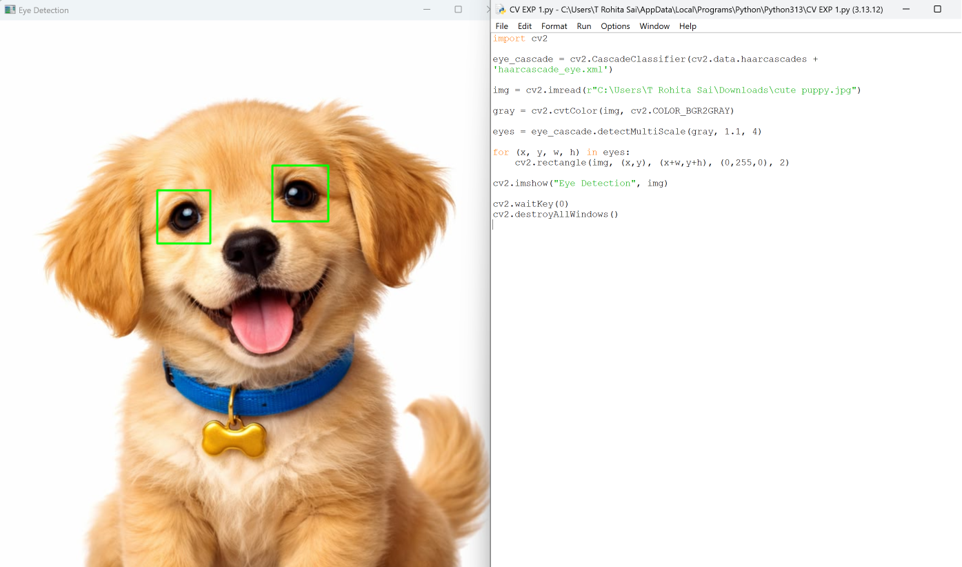

Experiment 30: Smile Detection
Code
import cv2
smile_cascade = cv2.CascadeClassifier(cv2.data.haarcascades +
'haarcascade_smile.xml')
img = cv2.imread(r"C:\Users\T Rohita Sai\Downloads\cute puppy.jpg")
gray = cv2.cvtColor(img, cv2.COLOR_BGR2GRAY)
smiles = smile_cascade.detectMultiScale(gray, 1.8, 20)
for (x, y, w, h) in smiles:
cv2.rectangle(img, (x,y), (x+w,y+h), (0,255,255), 2)
cv2.imshow("Smile Detection", img)
cv2.waitKey(0)
cv2.destroyAllWindows()
OUTPUT:

